**Aim: Program to simulate bus topology.**

**Code:**

#include "ns3/applications-module.h" #include "ns3/core-module.h" #include "ns3/csma-module.h" #include "ns3/internet-module.h"

#include "ns3/ipv4-global-routing-helper.h" #include "ns3/network-module.h"

#include "ns3/point-to-point-module.h"

// Default Network Topology

/

// 10.1.1.0

// n0 -------------- n1 n2 n3 n4

// point-to-point | | | |

// ================

// LAN 10.1.2.0

using namespace ns3;

NS_LOG_COMPONENT_DEFINE("SecondScriptExample"); int

main(int argc, char* argv[])

{

bool verbose = true; uint32_t nCsma = 3;

CommandLine cmd( FILE );

cmd.AddValue("nCsma", "Number of \"extra\" CSMA nodes/devices", nCsma); cmd.AddValue("verbose", "Tell echo applications to log if true", verbose); cmd.Parse(argc, argv);

if (verbose)

{

LogComponentEnable("UdpEchoClientApplication", LOG_LEVEL_INFO); LogComponentEnable("UdpEchoServerApplication", LOG_LEVEL_INFO);

}

nCsma = nCsma == 0 ? 1 : nCsma; NodeContainer p2pNodes; p2pNodes.Create(2); NodeContainer csmaNodes; csmaNodes.Add(p2pNodes.Get(1)); csmaNodes.Create(nCsma);

PointToPointHelper pointToPoint pointToPoint.SetDeviceAttribute("DataRate", StringValue("5Mbps")); pointToPoint.SetChannelAttribute("Delay", StringValue("2ms")); NetDeviceContainer p2pDevices;

p2pDevices = pointToPoint.Install(p2pNodes); CsmaHelper csma;

csma.SetChannelAttribute("DataRate", StringValue("100Mbps")); csma.SetChannelAttribute("Delay", TimeValue(NanoSeconds(6560))); NetDeviceContainer csmaDevices;

csmaDevices = csma.Install(csmaNodes); InternetStackHelper stack; stack.Install(p2pNodes.Get(0)); stack.Install(csmaNodes); Ipv4AddressHelper address;

address.SetBase("10.1.1.0", "255.255.255.0");

Ipv4InterfaceContainer p2pInterfaces; p2pInterfaces = address.Assign(p2pDevices); address.SetBase("10.1.2.0", "255.255.255.0");

Ipv4InterfaceContainer csmaInterfaces;

csmaInterfaces = address.Assign(csmaDevices); UdpEchoServerHelper echoServer(9);

ApplicationContainer serverApps = echoServer.Install(csmaNodes.Get(nCsma)); serverApps.Start(Seconds(1.0));

serverApps.Stop(Seconds(10.0));

UdpEchoClientHelper echoClient(csmaInterfaces.GetAddress(nCsma), 9); echoClient.SetAttribute("MaxPackets", UintegerValue(1)); echoClient.SetAttribute("Interval", TimeValue(Seconds(1.0))); echoClient.SetAttribute("PacketSize", UintegerValue(1024)); ApplicationContainer clientApps = echoClient.Install(p2pNodes.Get(0)); clientApps.Start(Seconds(2.0));

clientApps.Stop(Seconds(10.0)); Ipv4GlobalRoutingHelper::PopulateRoutingTables(); pointToPoint.EnablePcapAll("second"); csma.EnablePcap("second", csmaDevices.Get(1), true); Simulator::Run();

**Output:**

Step1: open example folder

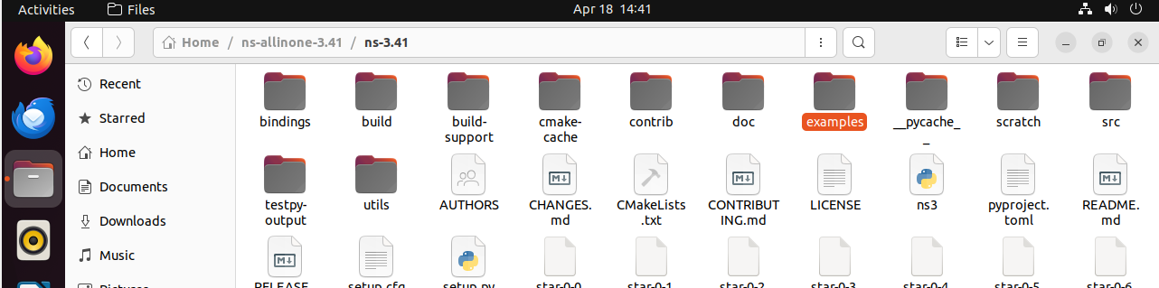

Step2: copy the second.cc file

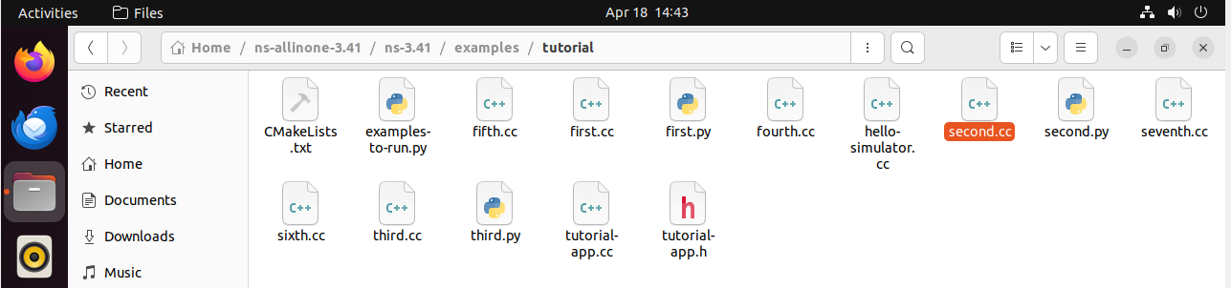

Step3: come back to ns-3.41 and open scratch folder

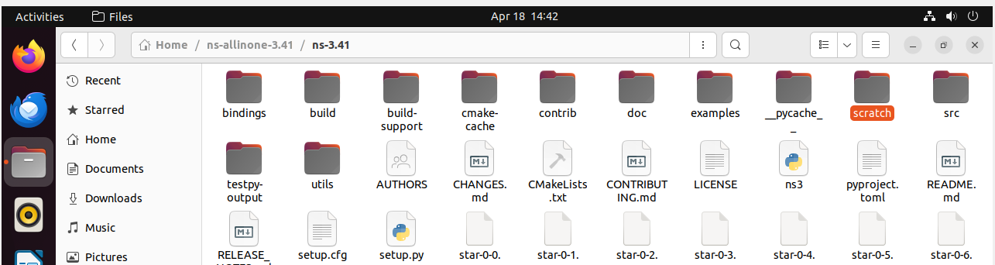

Step4:  Paste the second.cc file here

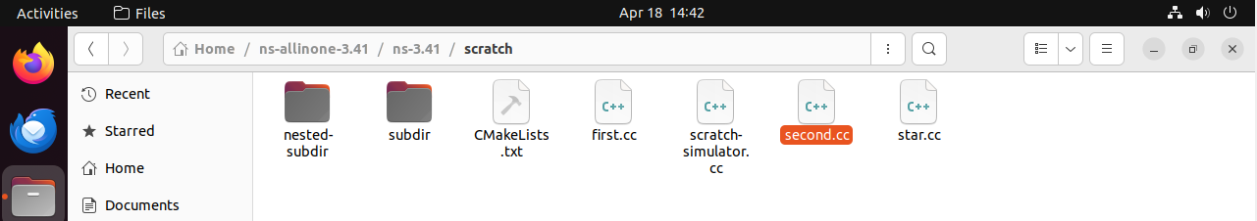

Step 5: Back to ns-3.41 file click on 3 dot it gives the option for open terminal run the command ./ns3 run scratch/second

